**Practical 03**

**Boot Sequence**

***Access the BIOS Setting***

1. Navigate to settings. You can get there by clicking the gear icon on the Start menu.

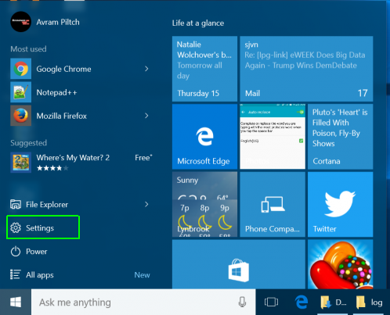

1. click on “Update & Security” at the bottom of the window.

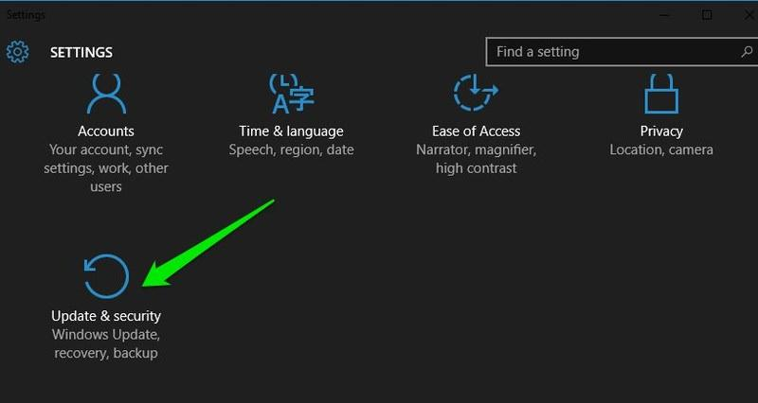

1. Here move to the**“Recovery”** option and click on **“Restart now”** under**“Advanced startup”** option. Your PC will now restart into advanced boot options.

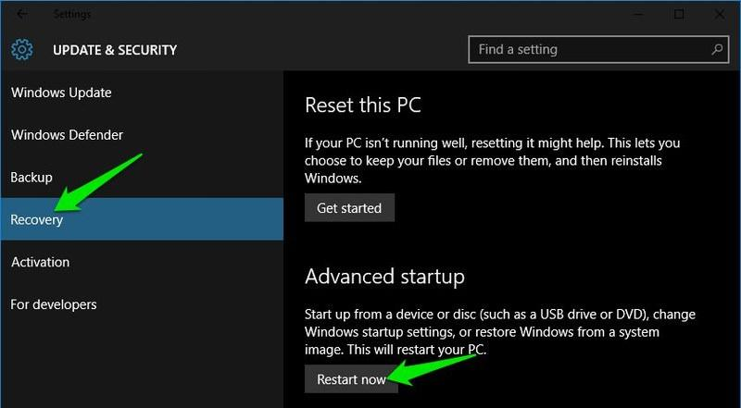

1. **Click Advanced options.**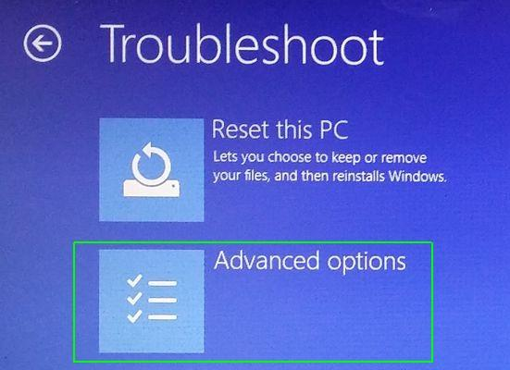
2. **Select UEFI Firmware Settings.**If you don't see this icon, then press Startup Settings, instead. When your PC is restarting, tap F1 (or F2) to access the BIOS.  
   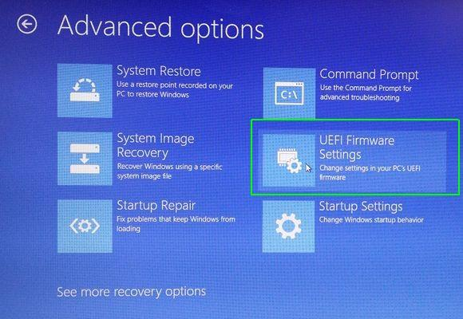

8. **Click Restart.**

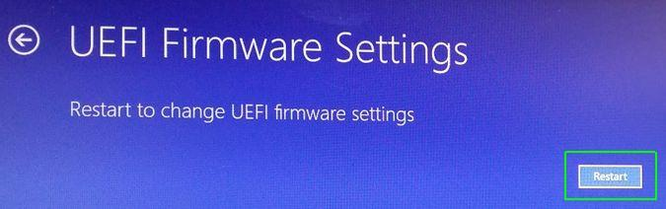

Your system will restart and take you to the BIOS.  
  
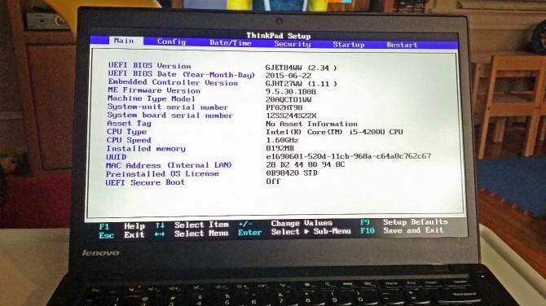

|  |
| --- |
| Windows 10 gives you a lot of options you can configure directly within the operating system, but on every computer, there are some settings you can only change in the BIOS (basic input / output system). The BIOS is the software that is built into your computer's motherboard and controls everything from the boot order of your drives to preboot security options to whether the Fn key on your keyboard activates a function key or a media control.  Unfortunately, because the BIOS is a pre-boot environment, you can't access it directly from within Windows.  Reference: <https://www.laptopmag.com/articles/access-bios-windows-10> |

What are different boot options for your PC? what is BIOS?

|  |
| --- |
| Different boot options for my PC are Windows Boot Manager, USB CD, USB FDD, NVMe0 WDC PC SN730 SDBQNTY-512G-101, NVMe1, ATA HDD0, ATA HDD1, ATA HDD2, USB HDD, PXE BOOT (Realtek UEFI UNDI Driver-IPv4, Realtek UEFI UNDI Driver-IPv6).  BIOS stands for basic input and output system. It is located in a chip on the motherboard and sends a set of instructions to the CPU when power is first supplied to the computer. One such instruction that the BIOS performs is a Power-On Self Test (POST) to check if essential parts such as the CPU, memory and storage devices are working properly. It is responsible for initializing and testing hardware components during the booting process. |

*End of Practical*